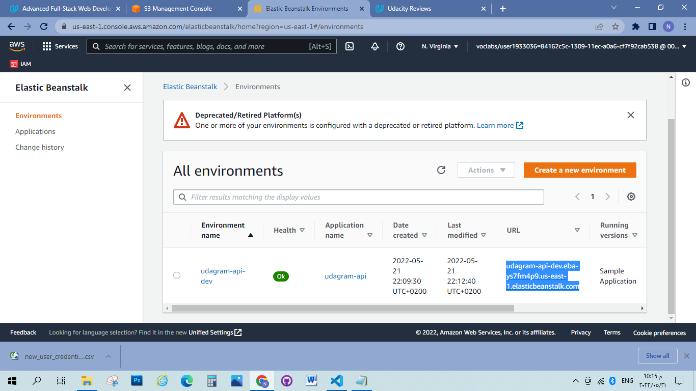

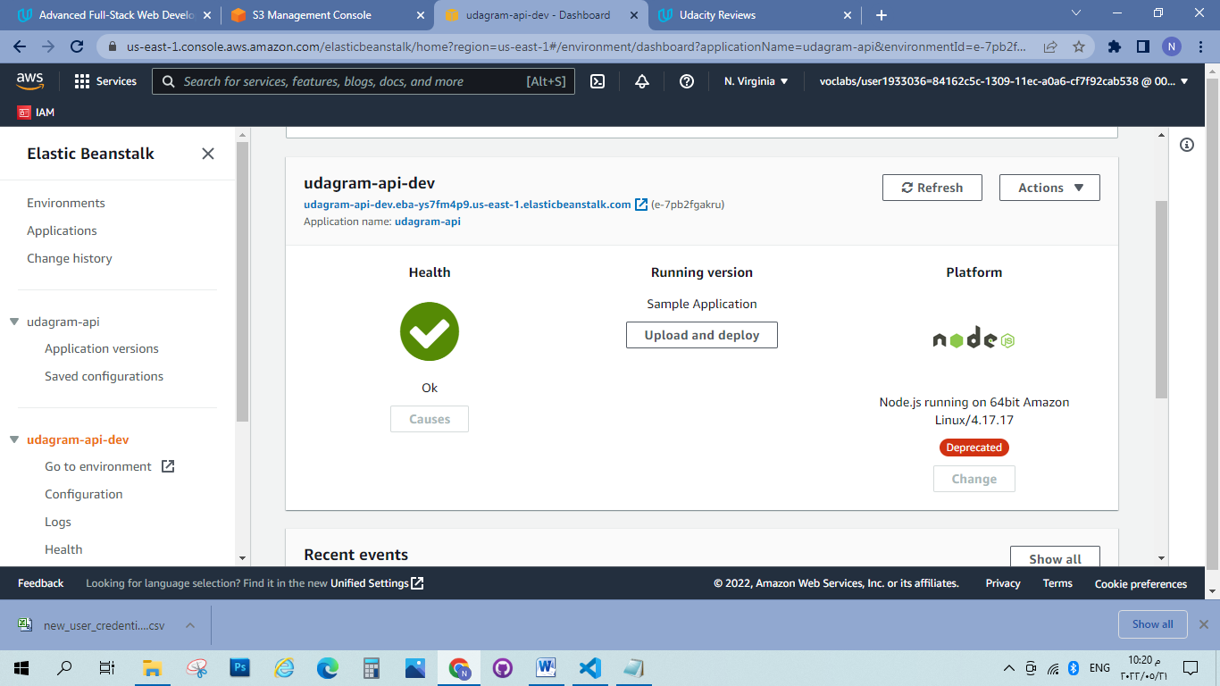

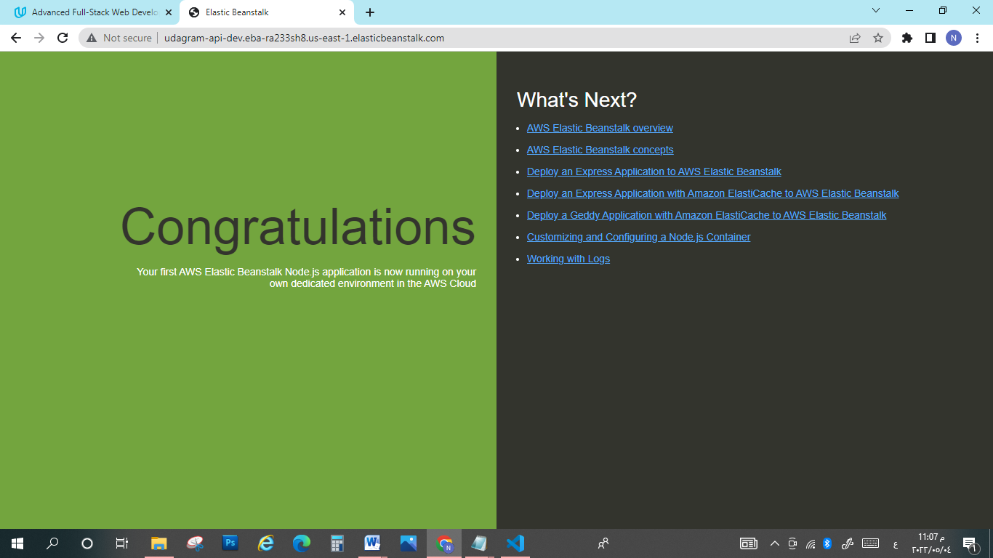

[udagram-api-dev.eba-ys7fm4p9.us-east-1.elasticbeanstalk.com](http://udagram-api-dev.eba-ys7fm4p9.us-east-1.elasticbeanstalk.com/)